Joseph Silva Jr.

SNHU – DAD 220

03/07/20

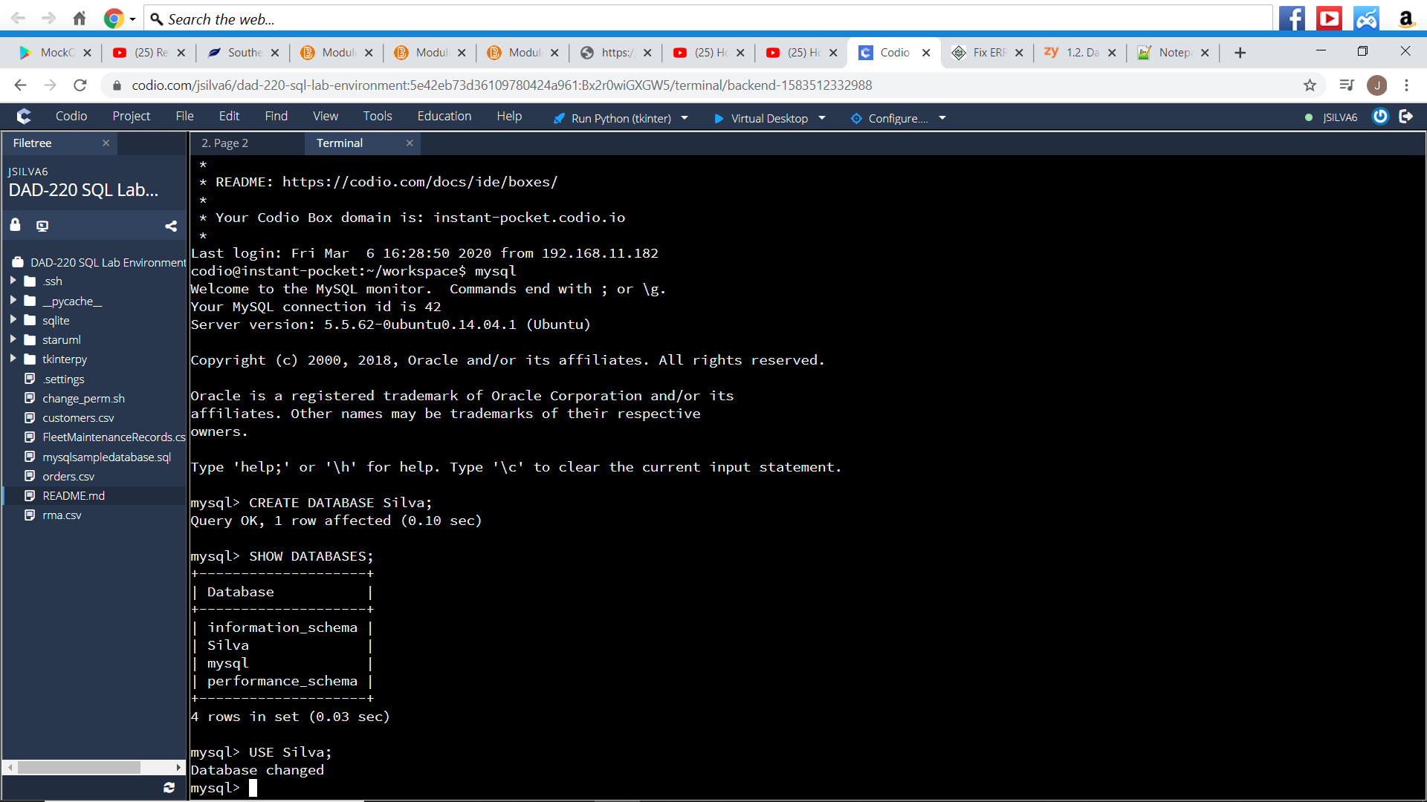

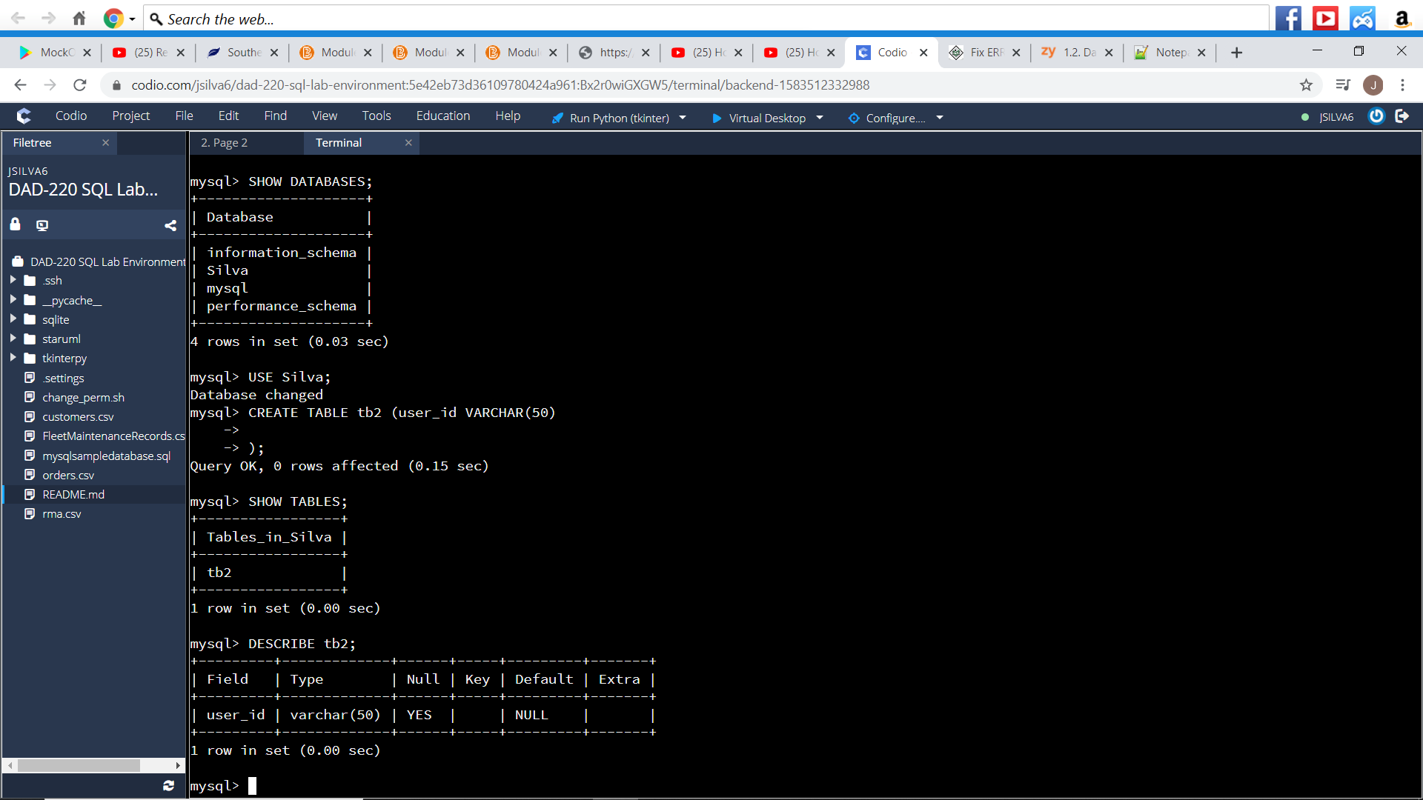

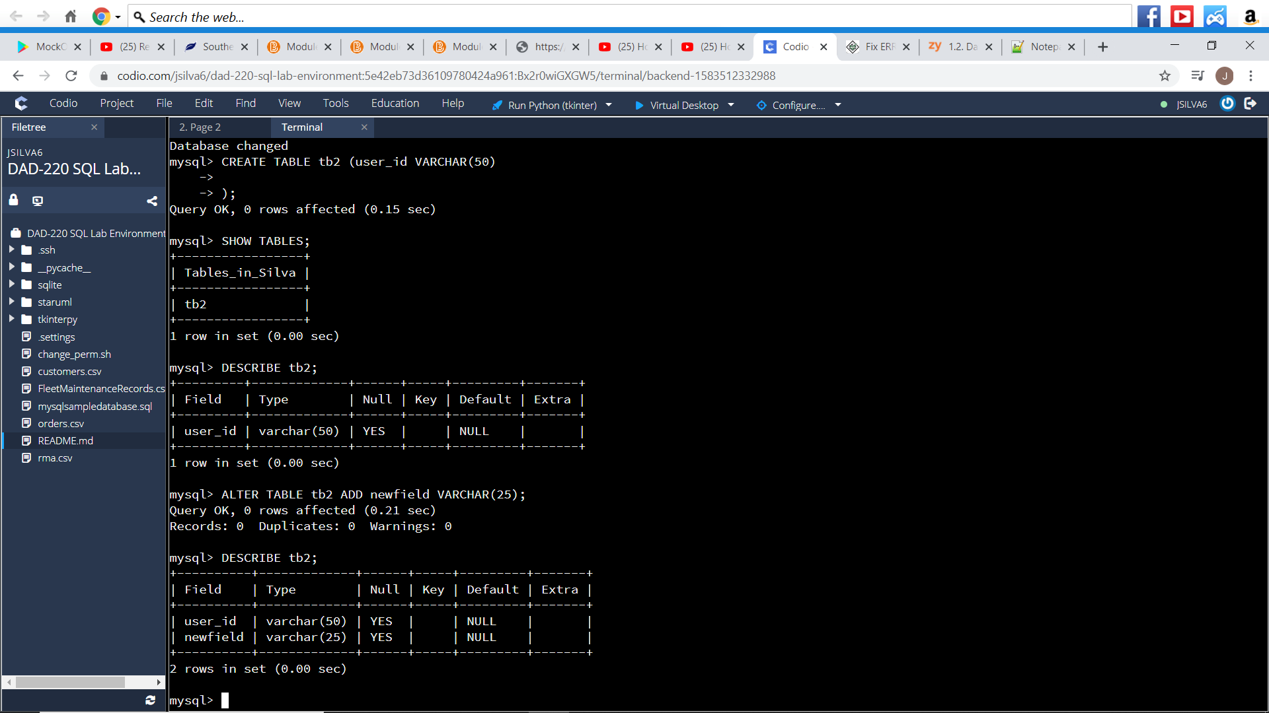

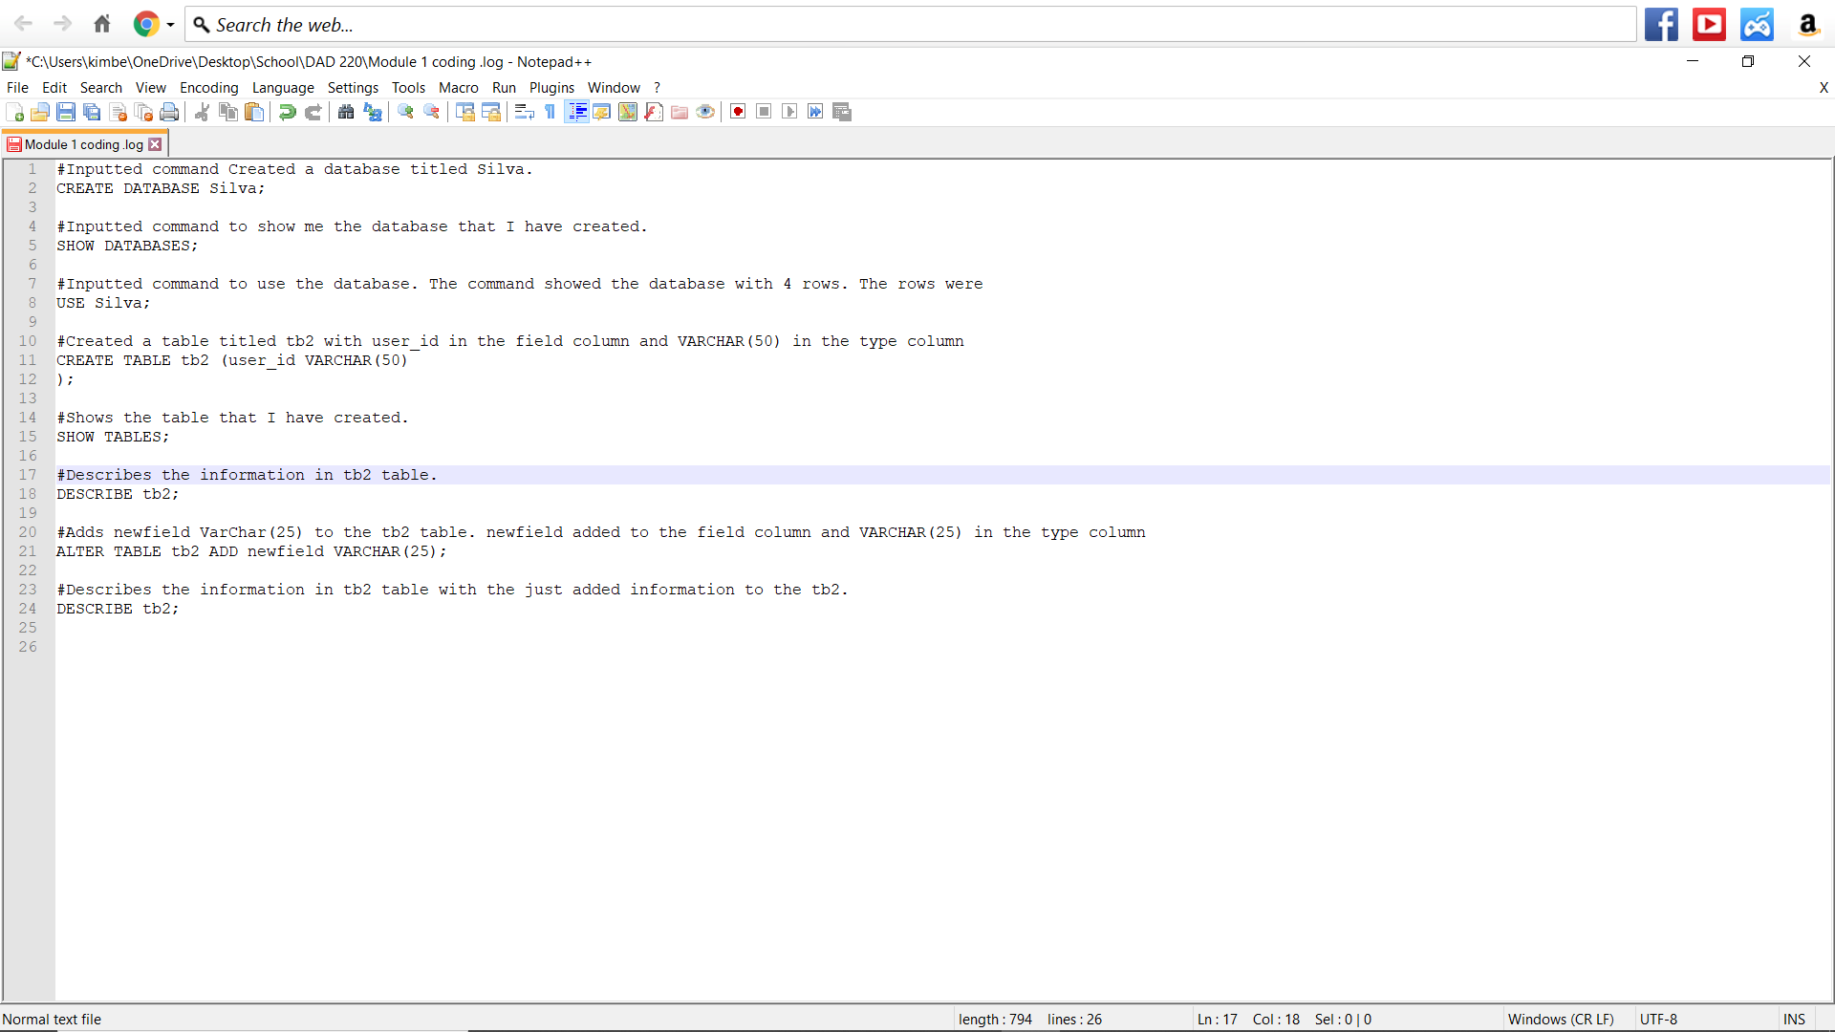

Coding + explanation: photograph above.

#Inputted command Created a database titled Silva.

CREATE DATABASE Silva;

#Inputted command to show me the database that I have created.

SHOW DATABASES;

#Inputted command to use the database. The command showed the database with 4 rows. The rows were

USE Silva;

#Created a table titled tb2 with user_id in the field column and VARCHAR(50) in the type column

CREATE TABLE tb2 (user_id VARCHAR(50)

);

#Shows the table that I have created.

SHOW TABLES;

#Describes the information in tb2 table.

DESCRIBE tb2;

#Adds newfield VarChar(25) to the tb2 table. newfield added to the field column and VARCHAR(25) in the type column

ALTER TABLE tb2 ADD newfield VARCHAR(25);

#Describes the information in tb2 table with the just added information to the tb2.

DESCRIBE tb2;